ILCA Boat Guide

The primary focus of this guide is to outline the proper procedure for returning the boats after use, to ensure that all members can continue to enjoy the sport and club activities.

Internal bung
After use of the boat the internal bung will need to be removed to allow the boat to self-drain in case of any rain. The bung should be attached to the boat via a small rod.
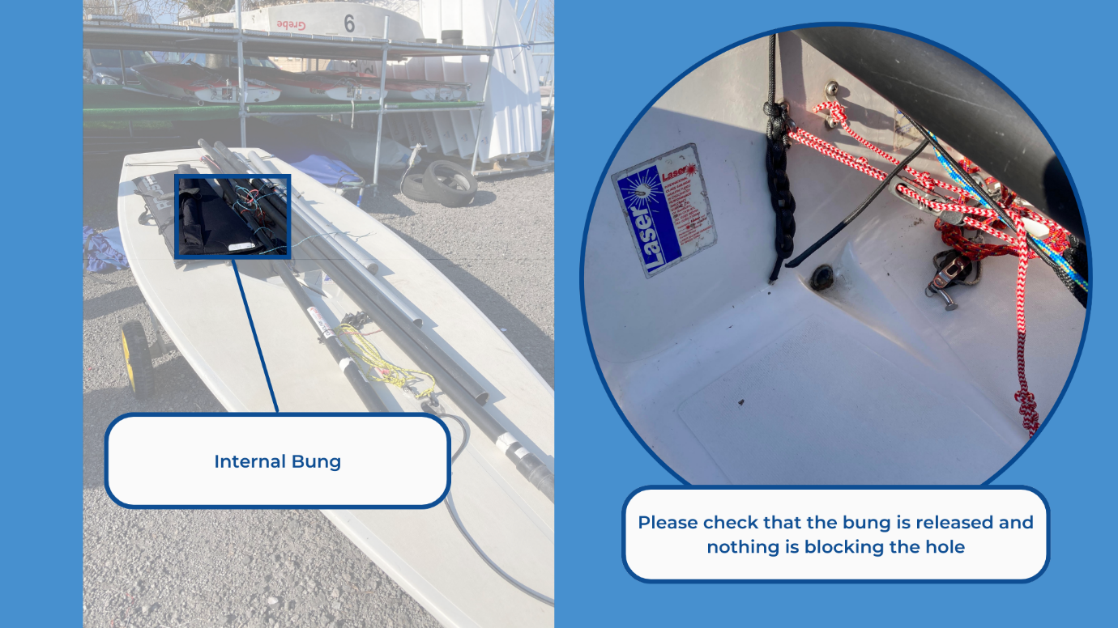

Sails
The boats have 3 sets of sails: 4.7, Radial and Standard. Sails should be stored in labelled bags and on the correct shelf for the set. Please ensure that sails return to the correct labelled bag. Battens for sails can be found in the ILCA/Laser foil bag, all battens have their sizes written on them. Please ensure that battens are firmly within the batten pocket before sailing. Clew straps are also stored in the foil bag pocket.

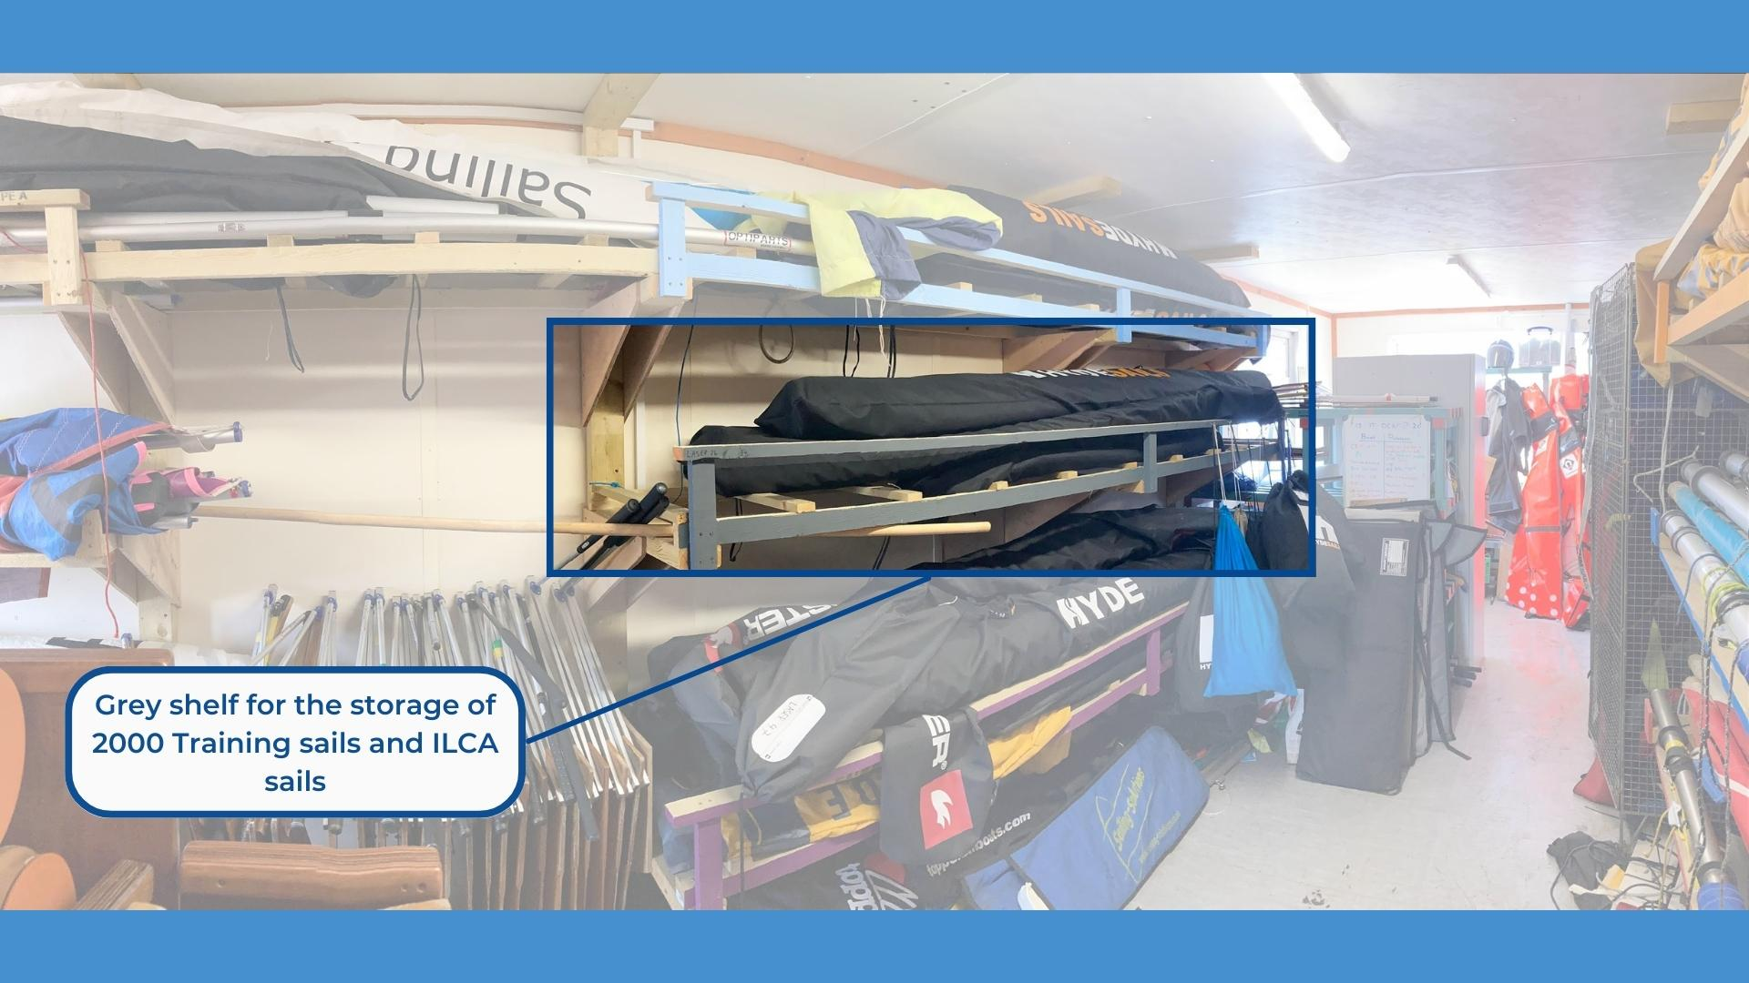
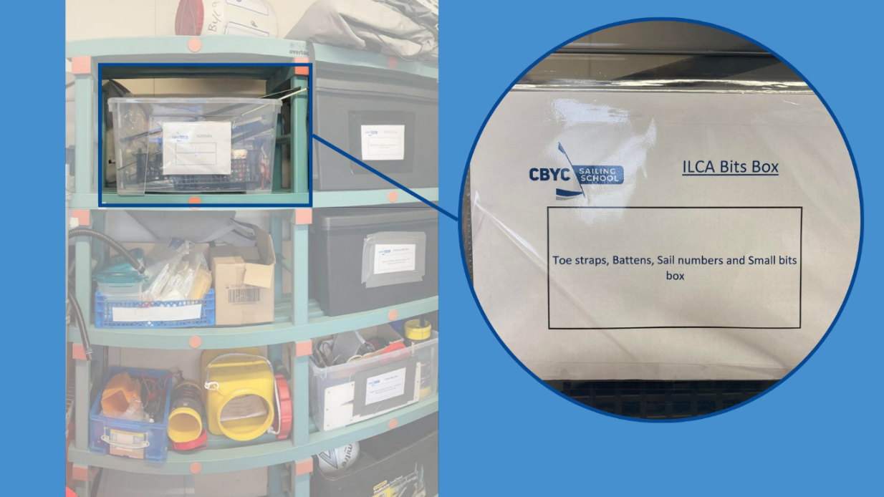

Foils
The rudder and daggerboard will need to be put back into their bag, ensuring that the zip is able to be done up. The tiller and tiller extension will need to be separated at the universal joint and then put into the sleeve on the back of the bag. Once in its bag it can be placed into the boat laying alongside the spars on the deck.
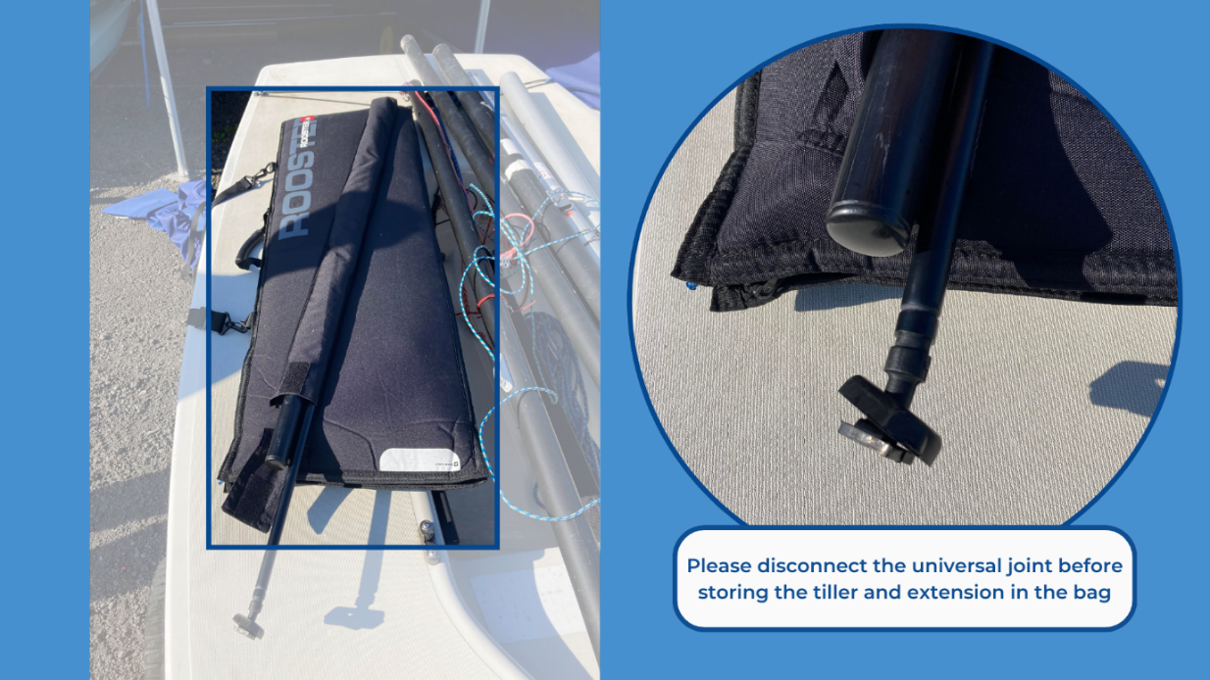

Covers
The boat covers will need to be put back onto the boat after use. Make sure that all straps are done up and are not hanging loose. At the bow you will need to tie the painter through the cover and back onto the trolley. At the stern you will need to tuck the strap under the rudder flap to prevent the back of the cover blowing around.
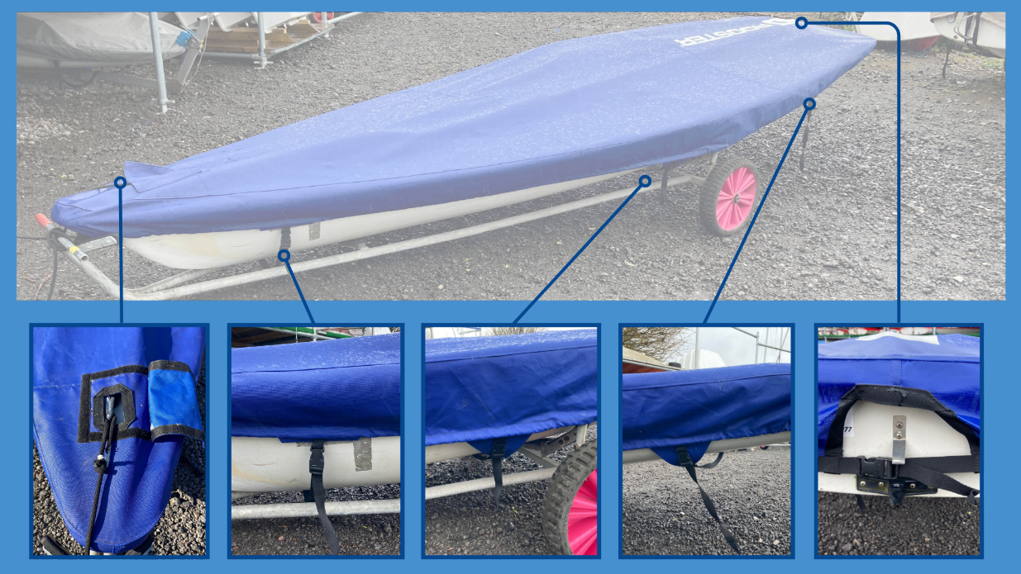

Trolley
To keep the boats in the best condition they must be stored on the correct type of trolley for the boat. Our trolleys are all labelled with an identifying sticker placed on or near the handles, the stickers indicate the type of trolley and which number trolley it is. If possible, boats should be returned to the same number trolley as the boat number.

Report any damage via QR code
If you become aware of any damage or maintenance required on the boat whilst sailing or ashore, please use the QR code to inform us of the issue. Whilst completing the form provide as much information as possible as this will help us to solve the issue sooner, allowing the boat to be used by others.
https://www.cognitoforms.com/CardiffBayYachtClub1/CBYCDinghyMaintenanceLog

