2000 Boat Guide

The primary focus of this guide is to outline the proper procedure for returning the boats after use, in order to ensure that all members can continue to enjoy the sport and club activities.

Internal bung
After use of the boat the internal bung will need to be removed to allow the boat to self-drain in case of any rain. The bung should be attached to the boat via a small line. Please tuck the bung under the toe-strap to prevent the bung from rolling into the bung hole.
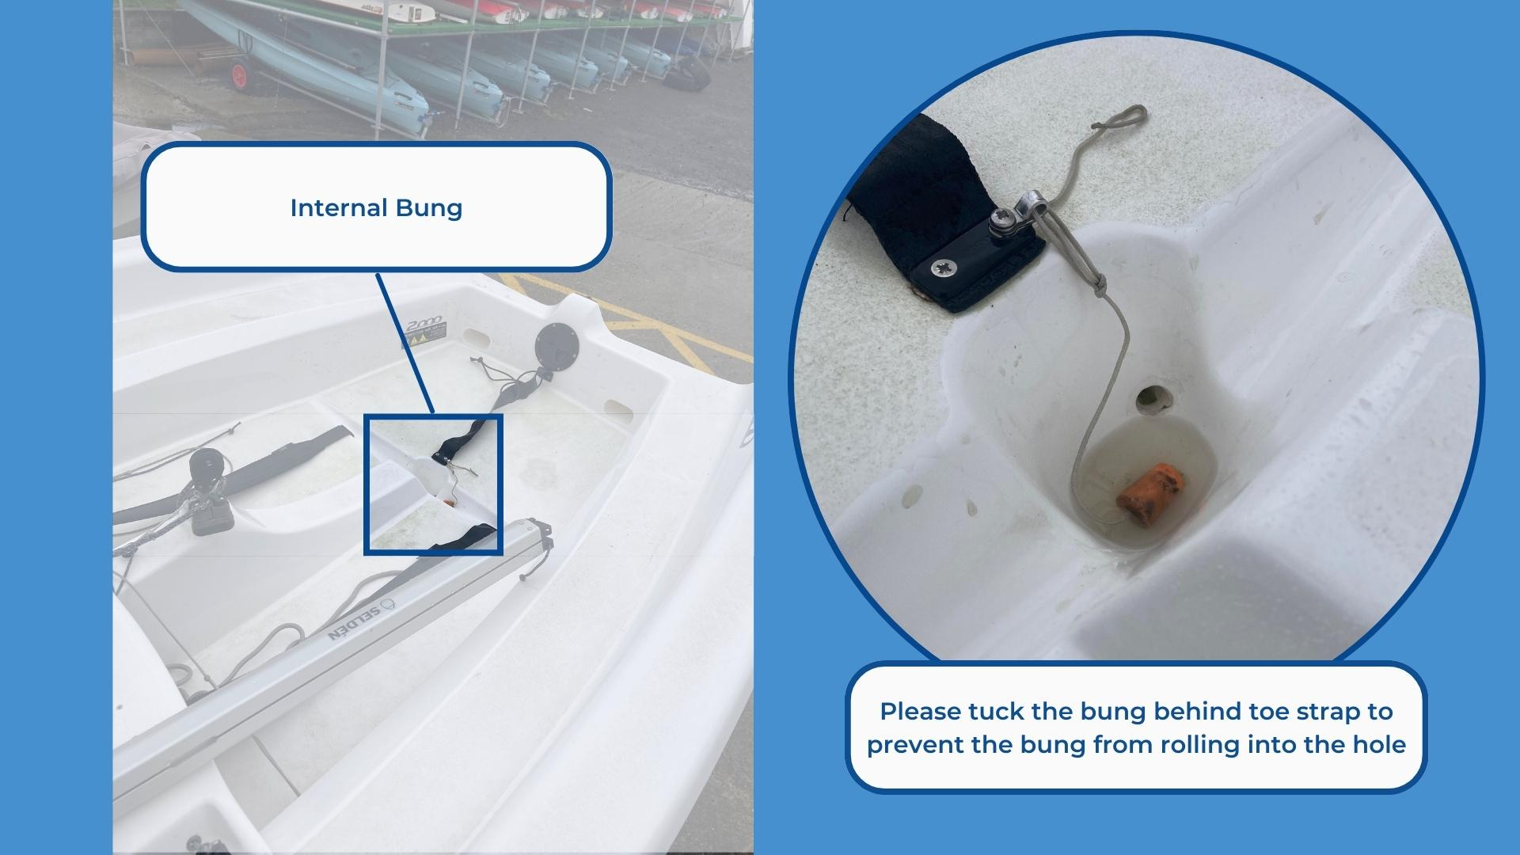

Sails
The boats have 2 sets of sails: Training and Racing. Racing sails may only be used if attending CBYC club racing. Sails should be stored in labelled bags and on the correct shelf for the set. Please ensure that sails are returned the correct labelled bag. We recommend putting the sail bags inside of each other so that you end up with 1 bag and storing this bag in a sensible location whilst you sail. The boats also have spinnakers available. After sailing please can you ensure that wet spinnakers are hung carefully in the shed to allow them to dry before being put back into their bags.
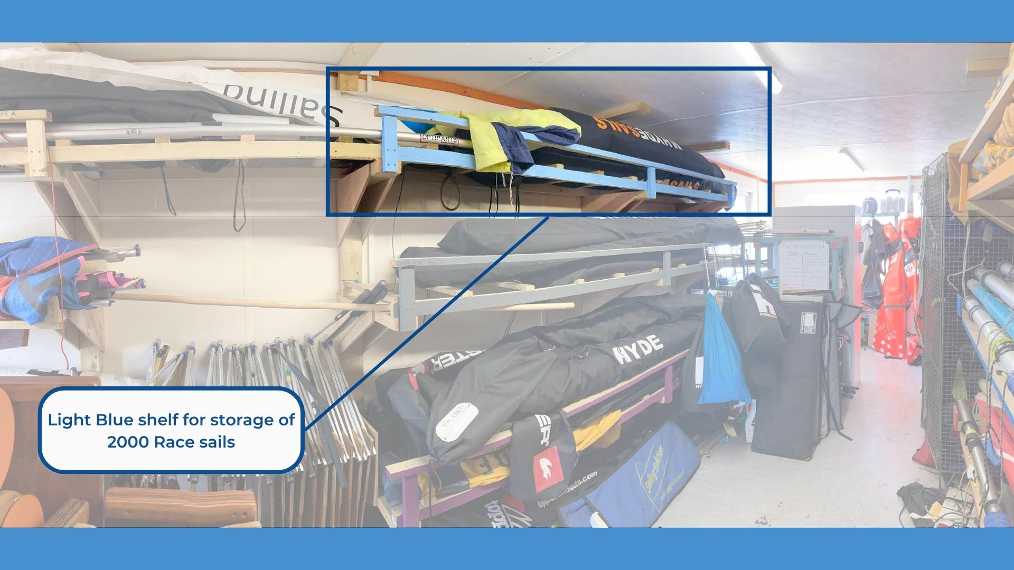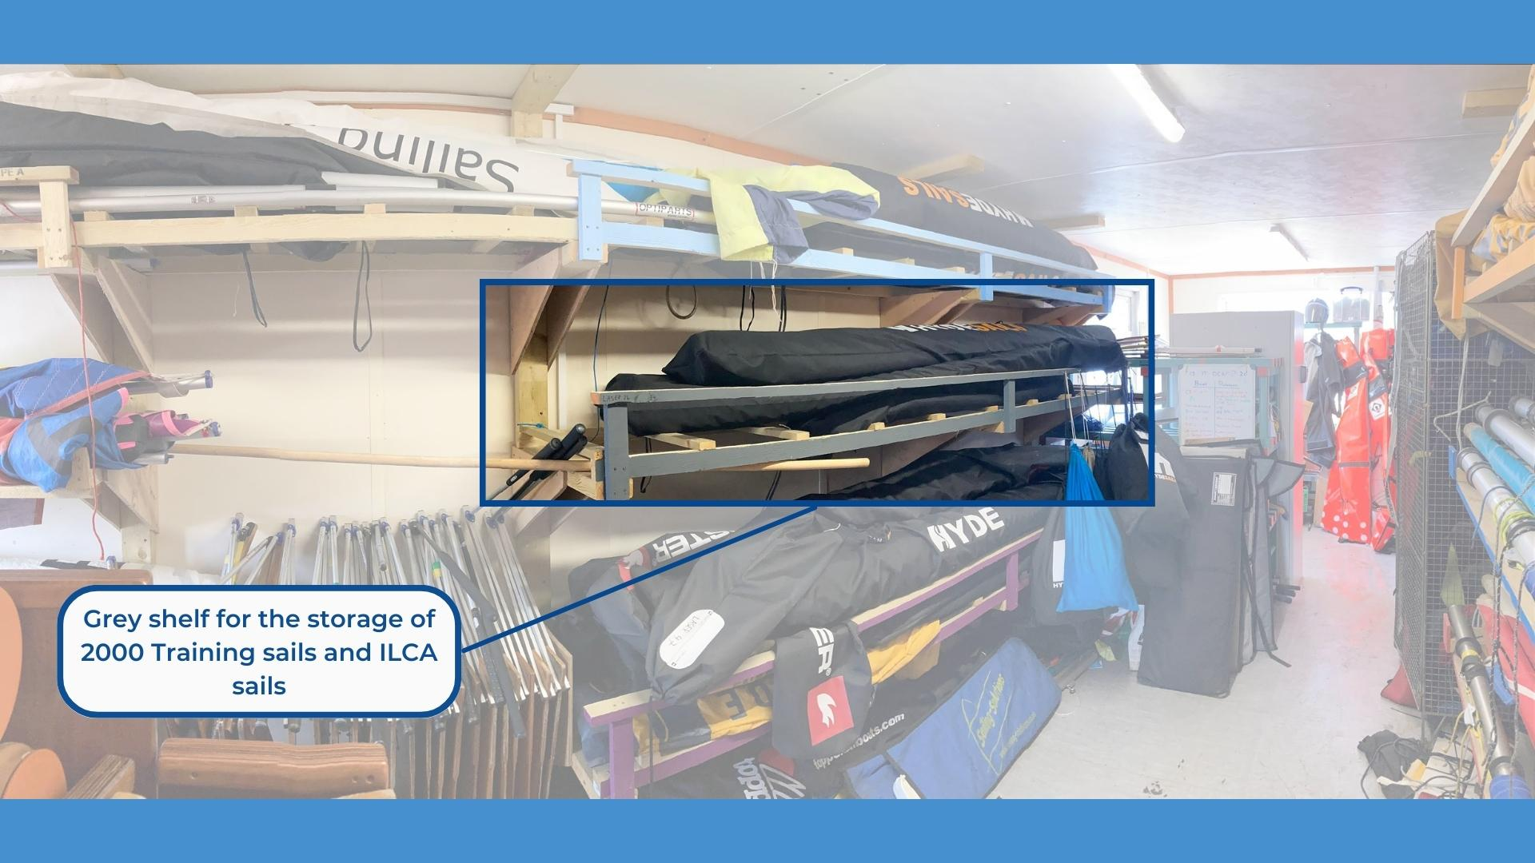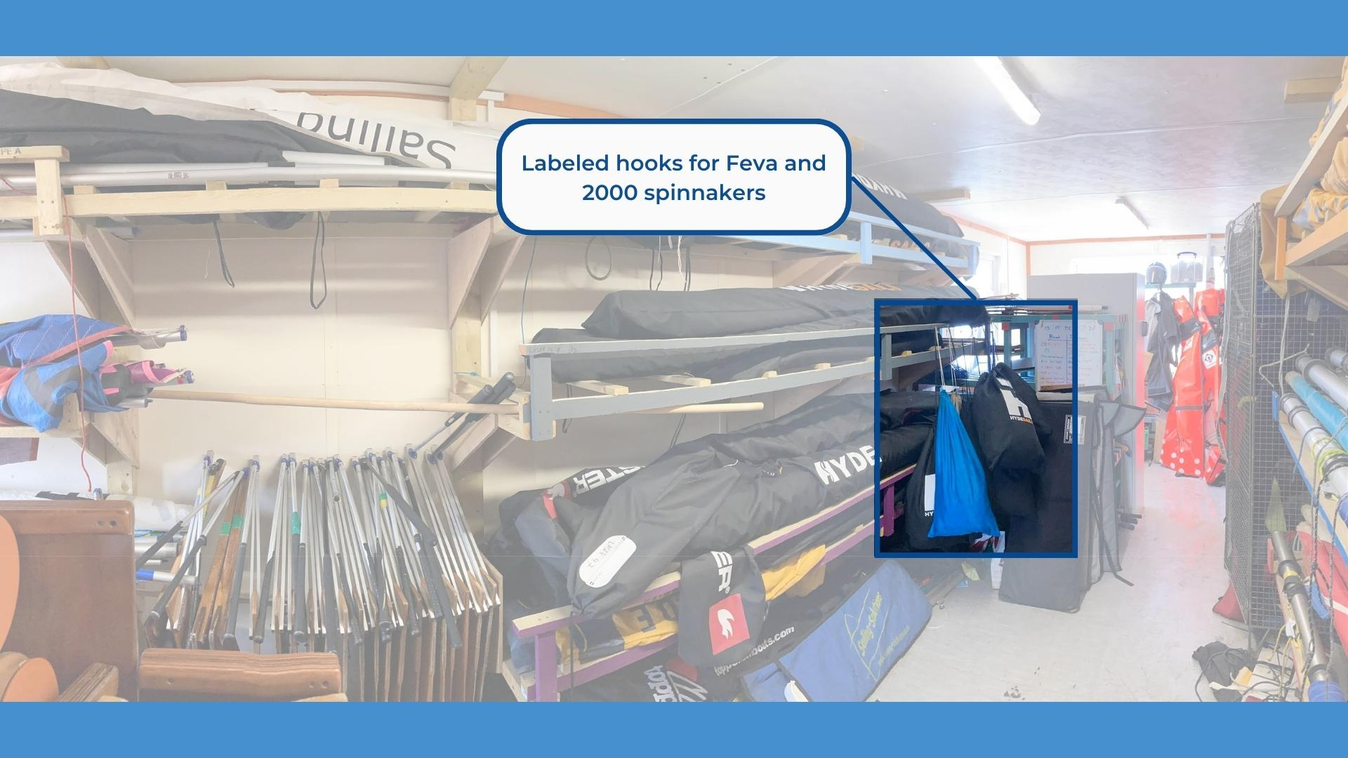

Foils
The rudder will need to be put back into its bag, ensuring that the Velcro is able to be done up. The rudder will need to be extended to have it fit into the bag. Once in its bag it can be placed into the boat laying alongside the centreboard casing.
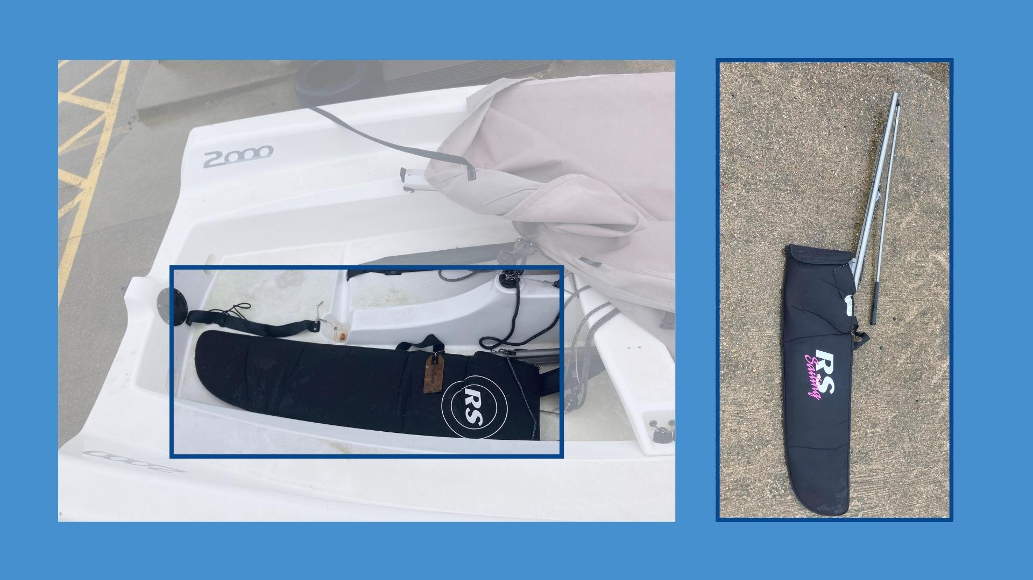

Mast head floats
It is up to you if you wish to use a mast head float. We recommend using 2 floats, if available, as it creates more buoyancy for the top of the mast. Floats can be found and returned to the ‘Training sails locker’ found outside the cabin.
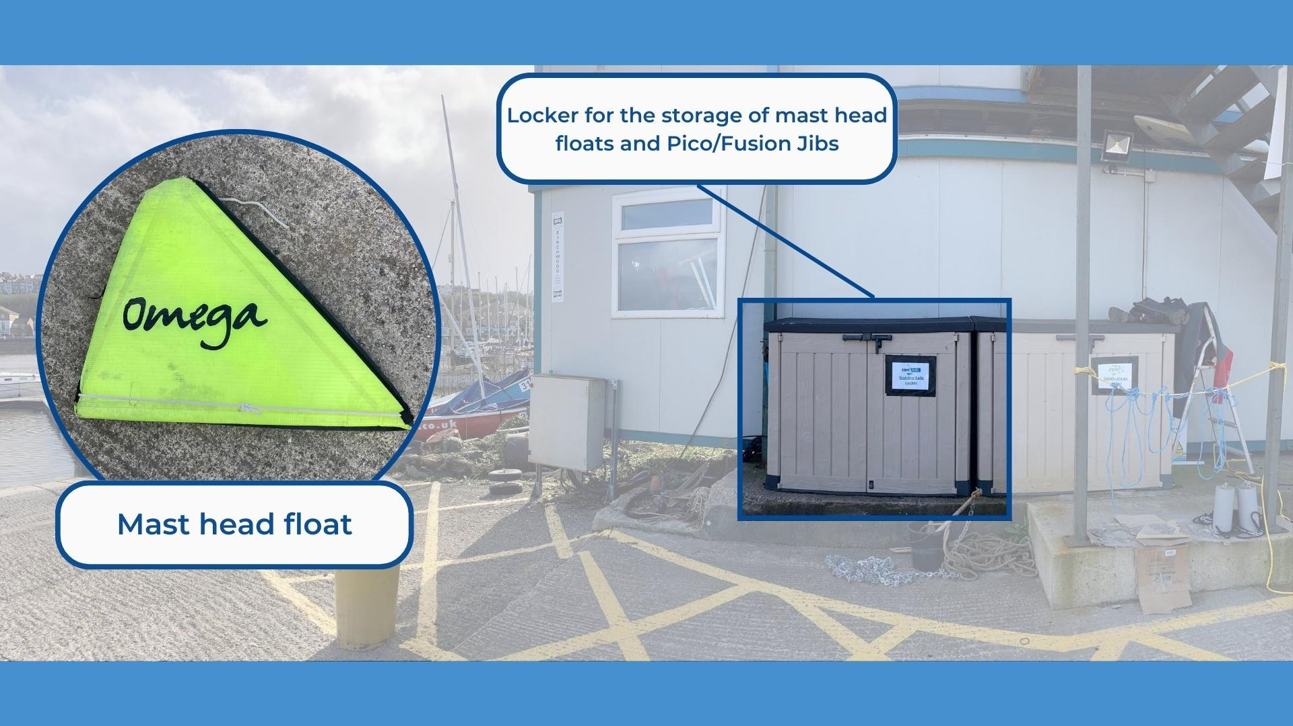

Covers
The boat covers will need to be put back onto the boat after use. Make sure that all straps are done up and are not hanging loose. At the stern you will need to tuck the white line under the rudder flap to prevent the back of the cover blowing around.
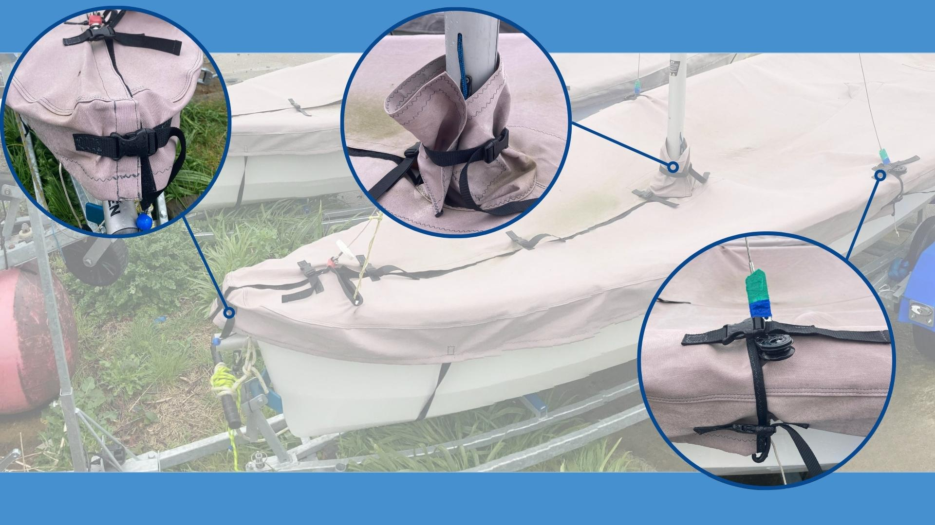
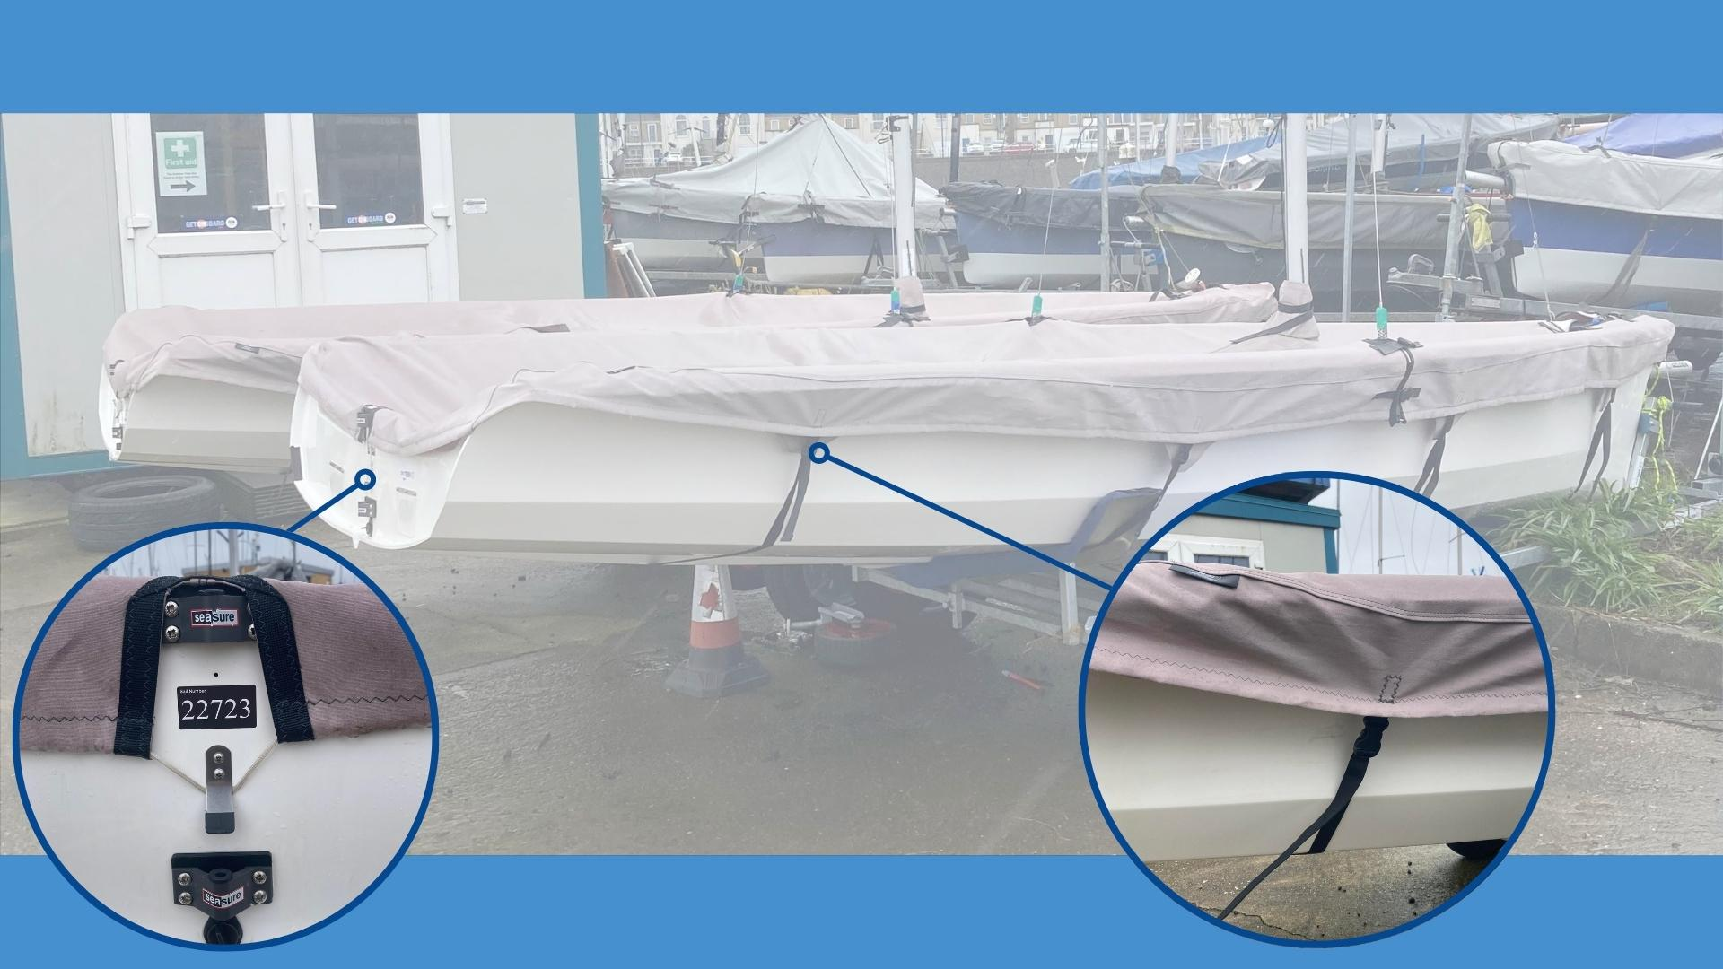

Trolley
To keep the boats in the best condition they must be stored on the correct type of trolley for the boat. Our trolleys are all labelled with an identifying sticker placed on or near the handles, the stickers indicate the type of trolley and which number trolley it is. If possible, boats should be returned to the same number trolley as the boat number .
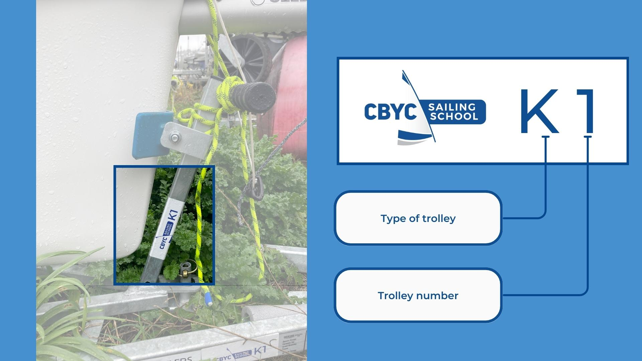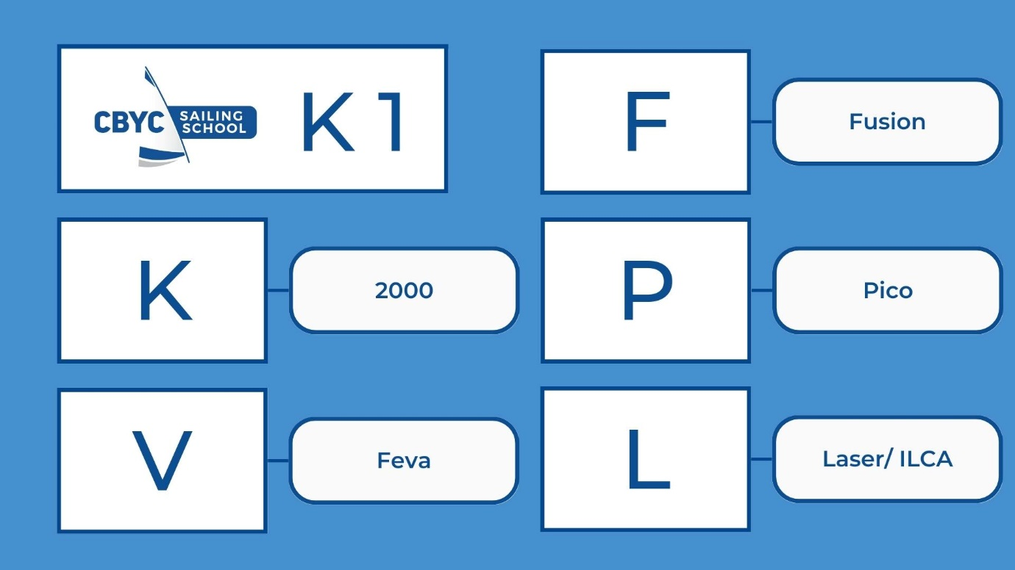

Propped up for draining
The boats will need to be propped up with a tyre so that the stern sits lower than the bow. This should promote any standing water build up to drain either through the transom flaps or the internal bung.

Report any damage via QR code
If you become aware of any damage or maintenance required on the boat whilst sailing or ashore, please use the QR code to inform us of the issue. Whilst completing the form provide as much information as possible as this will help us to solve the issue sooner, allowing the boat to be used by others.
https://www.cognitoforms.com/CardiffBayYachtClub1/CBYCDinghyMaintenanceLog

