Fusion Boat Guide

The primary focus of this guide is to outline the proper procedure for returning the boats after use, to ensure that all members can continue to enjoy the sport and club activities.

Sails
The boats have 2 sets of sails: Training and Racing. Racing sails may only be used if attending CBYC club racing. Training sails should be left on the mast whilst racing sails will go back into their bag. Racing sails have a set of 3 battens that will be stored in their bag. Please ensure that battens are firmly in the batten pocket before sailing. Jibs are also available on request.
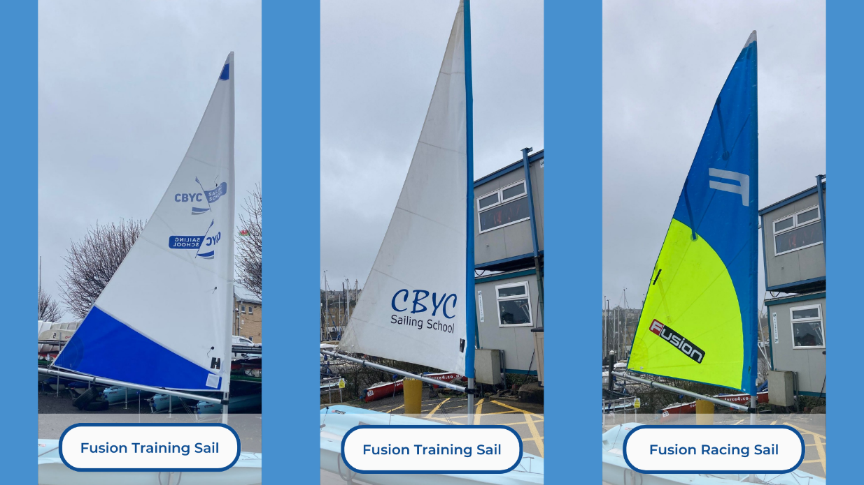
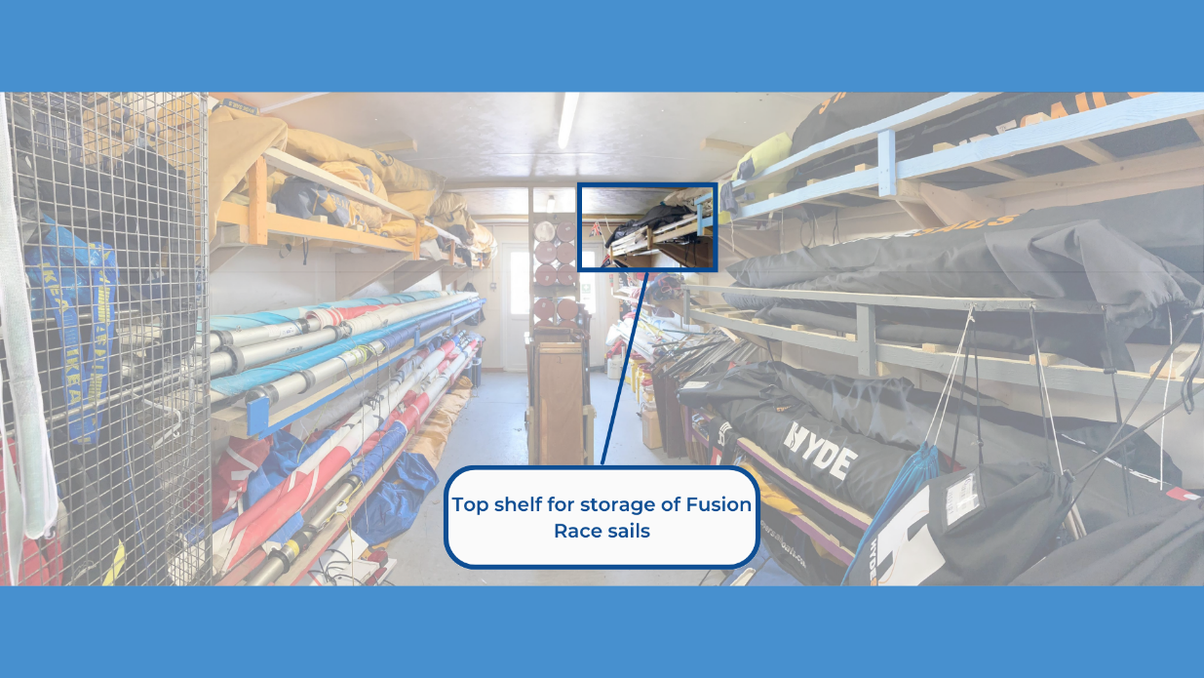

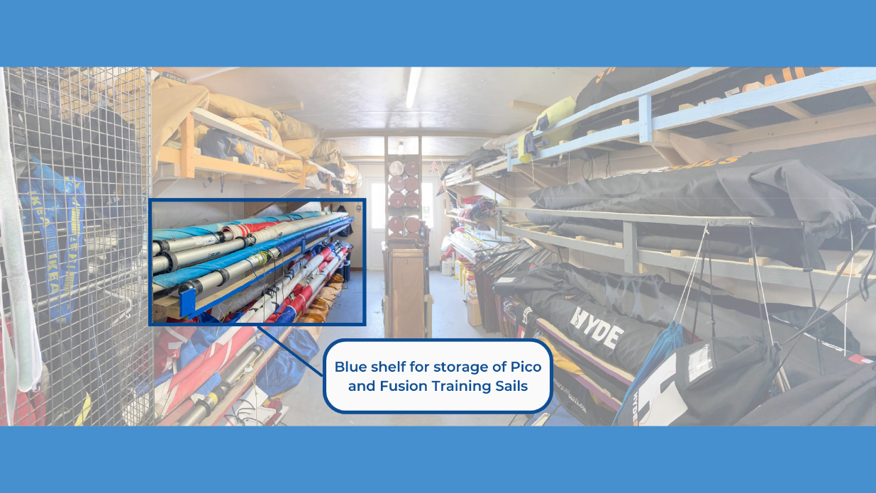

Foils
Please check that you have a split ring attached to the transom of the boat, this will need to be put onto the rudder pintle before sailing. Once finished you may place the rudder and daggerboard into the cockpit.
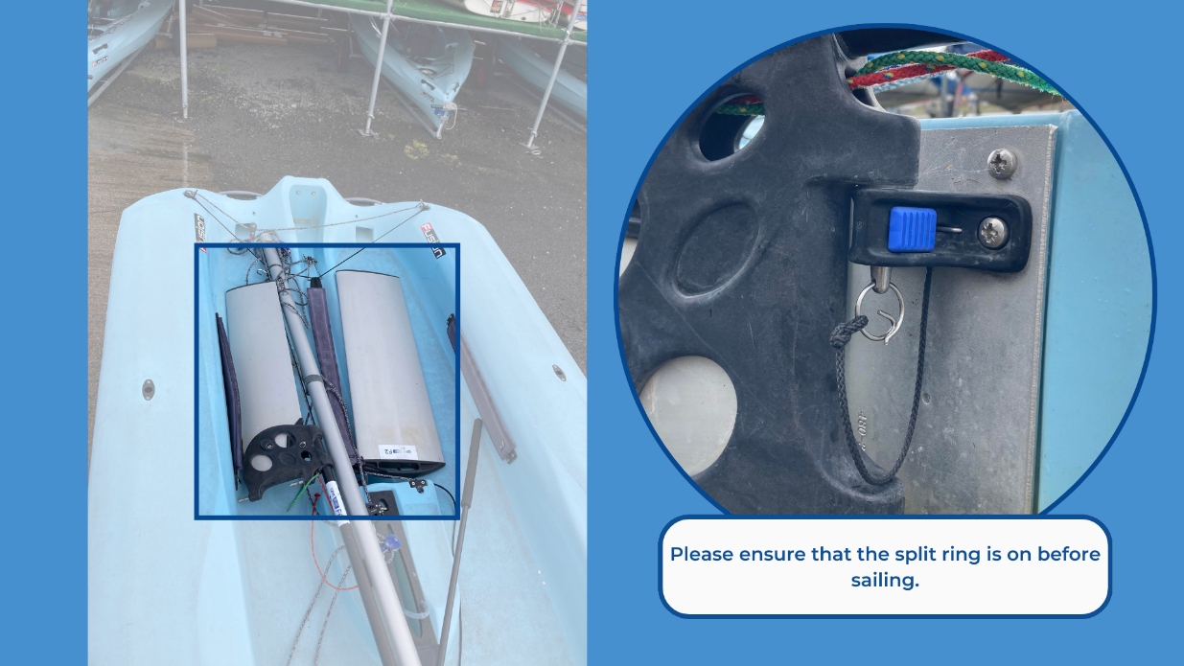

Mast head floats
It is up to you if you wish to use a mast head float. We recommend using 2 floats, if available, as it creates more buoyancy for the top of the mast. Floats can be found and returned to the ‘Training sails locker’ found outside the cabin.
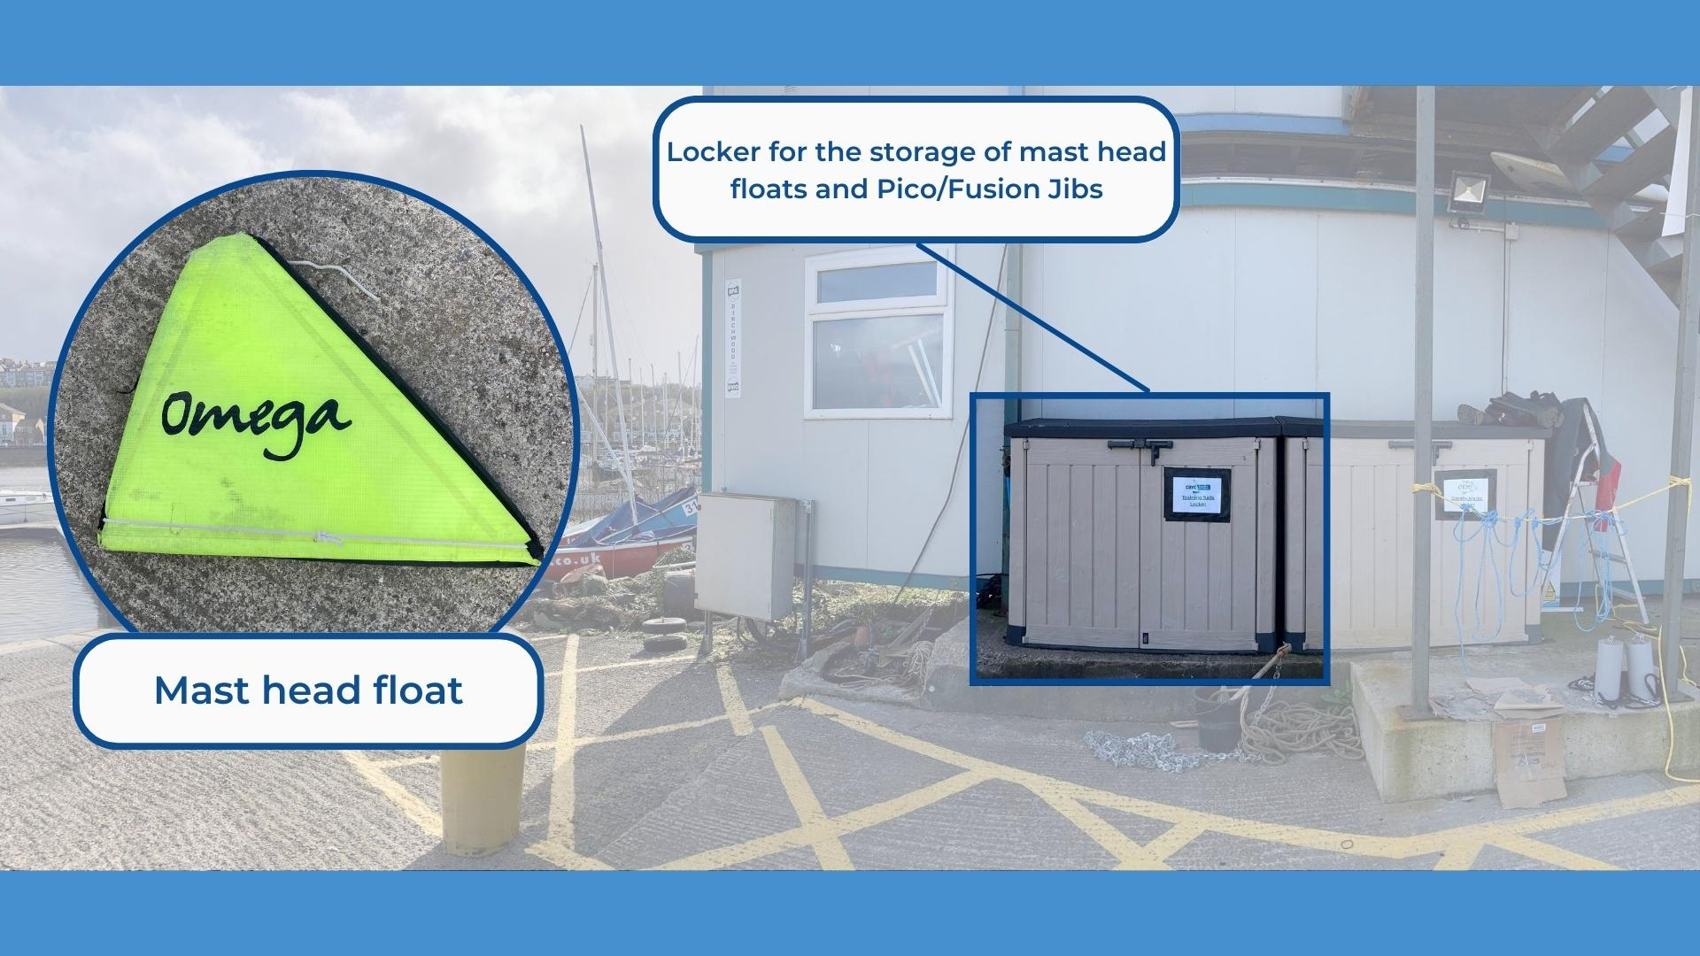

Trolley
To keep the boats in the best condition they must be stored on the correct type of trolley for the boat. Our trolleys are all labelled with an identifying sticker placed on or near the handles, the stickers indicate the type of trolley and which number trolley it is. If possible, boats should be returned to the same number trolley as the boat number. 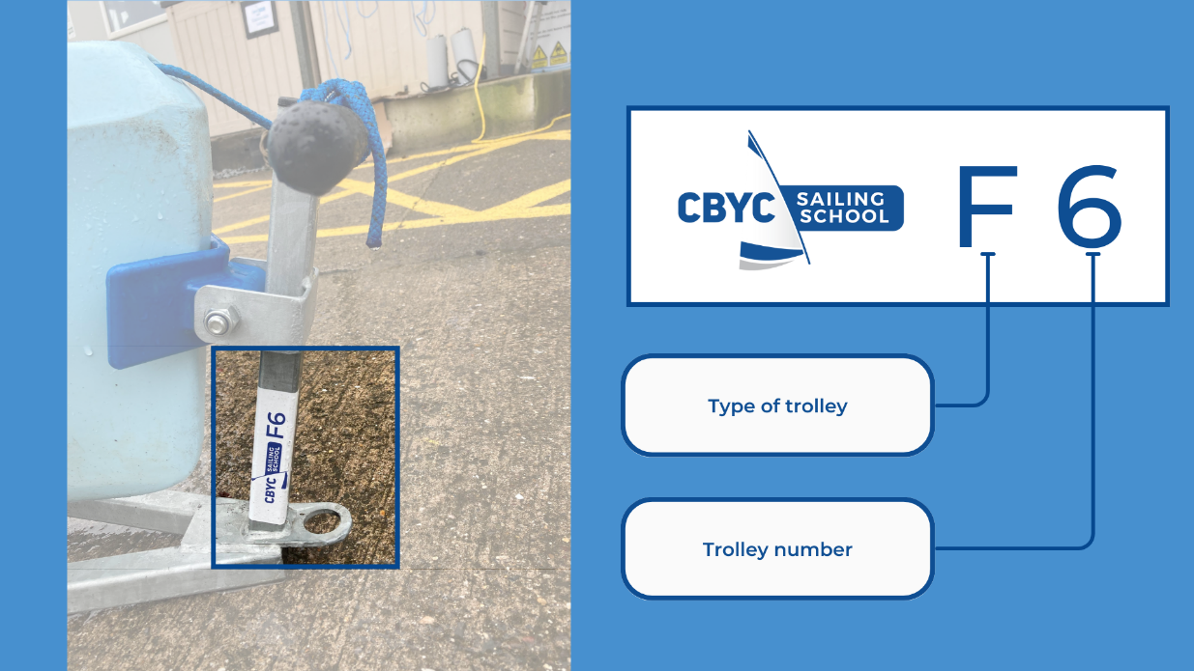
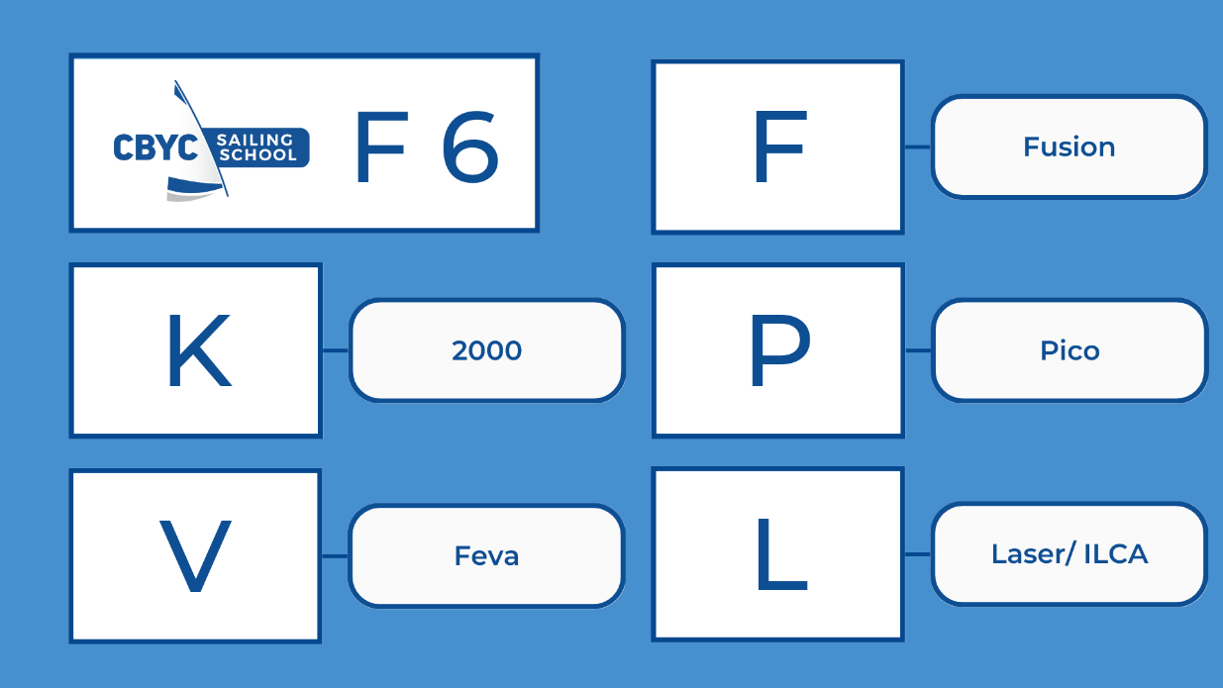

Propped up for draining
The boats will need to be propped up with a tyre so that the stern sits lower than the bow. This should promote any standing water build up to drain either through the transom flaps or the internal bung.

Report any damage via QR code
If you become aware of any damage or maintenance required on the boat whilst sailing or ashore, please use the QR code to inform us of the issue. Whilst completing the form provide as much information as possible as this will help us to solve the issue sooner, allowing the boat to be used by others.
https://www.cognitoforms.com/CardiffBayYachtClub1/CBYCDinghyMaintenanceLog

