2000 CLASS ASSOCIATION
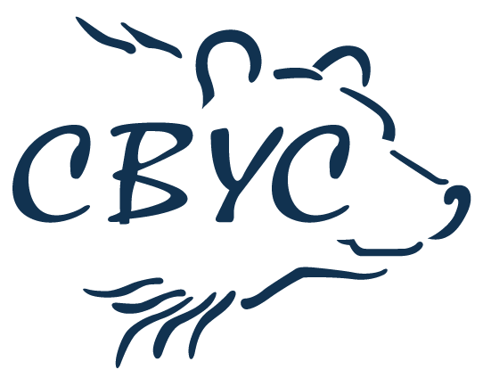

RS200 open meeting sponsored by
West Country Boat Repairs
29th October 2023

The Organising Authority is the Cardiff Bay Yacht Club in conjunction with RS200 Class Association

NOTICE OF RACE

- RULES
  - The regatta will be governed by the rules as defined in The Racing Rules of Sailing 2021–2024.
  - Competitors should note that the Organising Authority implements the RYA Racing Charter and that they will be expected to sail in compliance with it. The charter can be found at the front of the RYA edition of the Racing Rules of Sailing 2021–2024 or on the RYA website at www.rya.org.uk/racing/charter .
  - The RYA Arbitration of the RYA Rules Disputes procedures shall apply (for information, go to www.rya.org/uk/go/rulesdisputes ). The outcome of an RYA Arbitration can be referred to a protest committee, but an arbitration cannot be reopened or appealed. This changes RRS Part 5B, Rule 63.1.

- ELIGIBILITY & ENTRY
2.1 The event is open to all boats of the RS200 class.
  - Both the helm or crew of the boat shall be a member of the RS200 Class Association
  - Eligible boats shall enter by 10.30 am on 29th October. Payment details will be found on the entry form.
  - Parent/Guardian Declarations: All entries for helms and crews under 18 years of age during the event shall be completed by a parent/guardian. It is a rule of the Organising Authority that parents remain on the premises while under 18s compete or accompany them on the water.
  - The Organising Authority may cancel the event, cancel classes and reject or cancel entries in its absolute discretion, subject to RRS 76.

- FEES
  - Entry fee is £20 per boat.
  - Entries will only be accepted when payment in full has been made.

- SCHEDULE
  - Registration: Boats shall register online at www.cbyc.co.uk or in the Clubhouse by 10.30 am on 29th October 2023.
  - There will be a competitor briefing at 10.30 on Sunday 29th October 2023
  - It is intended to run 4 races.
  - It is intended to run races back-to-back.
  - On the last scheduled day of racing no warning signal will be made after 3pm

Day |  | Time
Sunday 29 October | First Warning Signal | 11.25 am | 4 races

5 MEASUREMENT
5.1 Boats may be inspected at any time.
  - Boats shall comply with RRS 78.1- Compliance with class rules

- SAILING INSTRUCTIONS
6.1 Sailing Instructions will be available online at www.cbyc.co.uk in advance of the event or at registration.

- VENUE
7.1 Racing will take place from:

Cardiff Bay Yacht Club,
Ferry Road,
Cardiff,
Wales,
United Kingdom
CF11 0JL

- THE COURSES
8.1 Course diagrams will be included in the Sailing Instructions.

- PENALTY SYSTEM
  - The Scoring penalty, RRS 44.1 applies

- SCORING
  - One race is required to be completed to constitute a series.
10.2 When 4 races are completed, there will be one discard.

- SUPPORT BOATS
  - Support boats with team leaders, coaches and other support personnel shall stay outside areas where boats are racing from the time of the starting sequence until all boats have finished, or the race committee signals a postponement, general recall or abandonment.

- BERTHING PARKING AND LAUNCHING
  - Boats shall be unloaded, rigged, and kept as directed by the Organising Authority.
  - There is limited parking at the venue and competitors are requested to park vehicles outside the Organising Authority’s venue after unloading.

- PRIZES
  - The prizes will be awarded at the discretion of the Organising Authority.

- RIGHTS TO USE NAMES & LIKENESSES
14.1 Competitors automatically grant to the Organising Authority and their sponsors without payment the right in perpetuity to make, use and show any motion pictures, still pictures and live, taped, or filmed television of or relating to the event.

- RISK STATEMENT

15.1 Rule 4 of the Racing Rules of Sailing states: ‘The responsibility for a boat’s decision to participate in a race or to continue racing is hers alone.’

15.2 Sailing is by its nature an unpredictable sport and therefore inherently involves an element of risk. By taking part in the event, each competitor agrees and acknowledges that:

They are aware of the inherent element of risk involved in the sport and accept responsibility for the exposure of themselves, their crew and their boat to such inherent risk whilst taking part in the event;

They are responsible for the safety of themselves, their crew, their boat, and their other property whether afloat or ashore;

They accept responsibility for any injury, damage or loss to the extent caused by their own actions or omissions;

Their boat is in good order, equipped to sail in the event and they are fit to participate;

The provision of a race management team, patrol boats, umpires and other officials and volunteers by the event organiser does not relieve them of their own responsibilities;

The provision of patrol boat cover is limited to such assistance, particularly in extreme weather conditions, as can be practically provided in the circumstances.

It is their responsibility to familiarise themselves with any specific risks to this venue or this event drawn to their attention in any rules and information produced for the event and to attend any safety briefing at the venue

- INSURANCE
16.1 Each participating boat shall be insured with valid third-party liability insurance with a minimum cover of £3 million per event or the equivalent.
__________________________________________________________

FURTHER INFORMATION

For venue information visit www.cbyc.co.uk

